Setting the Arduino IDE
- Installing TLS2591 library from Arduino IDE’s library manager
  - Open the library manager
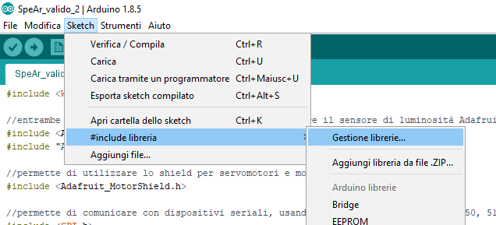
  - Search the library “tsl2591” and install the first one (select it and click “install”)
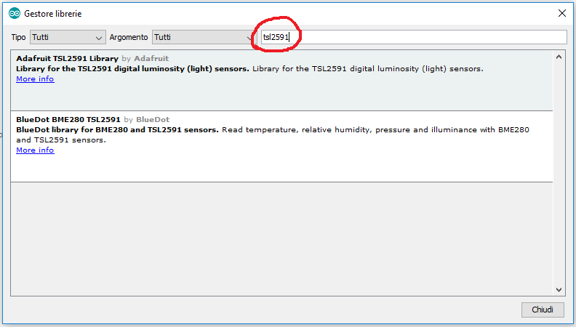
  - Then search “adafruit unified sensor” and install it (you would probably have to scroll down a bit)
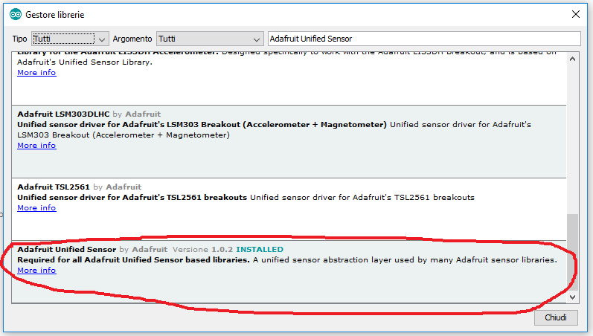
  - Search “servo motor” and install the version2
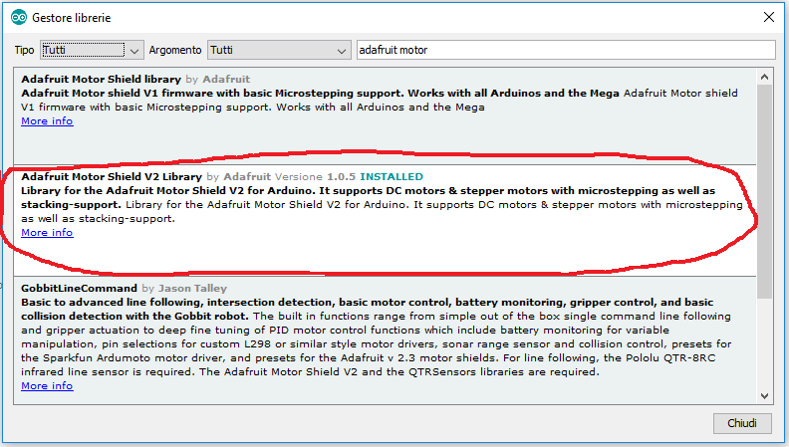
  - Search “keypad” and install the highlighted one
